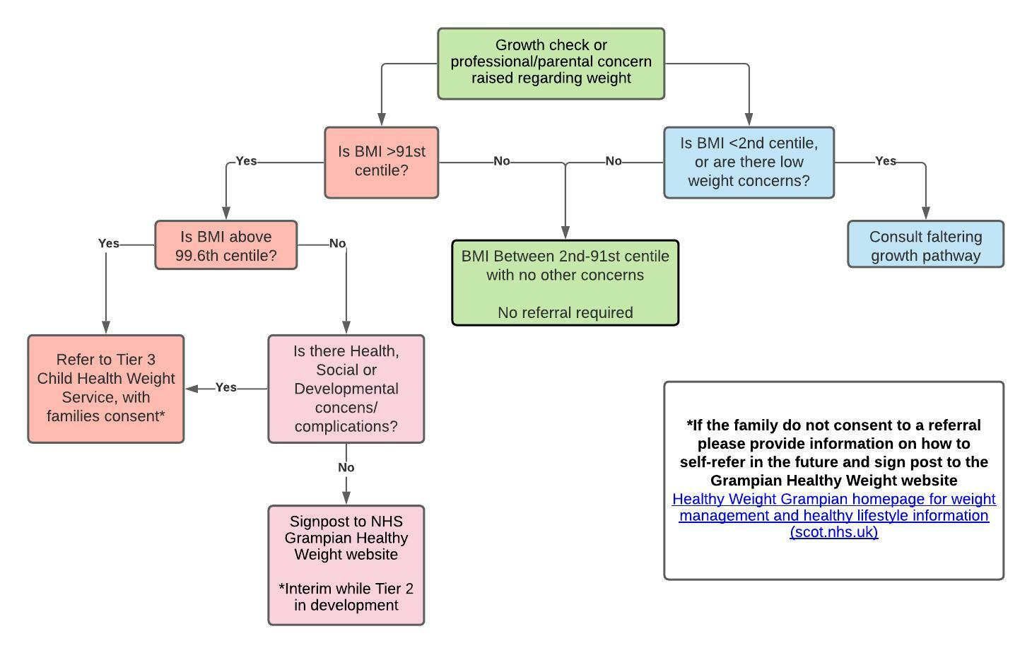

**\*if the family do not consent to a referral please provide information on how to self-refer in the future and sign post to the Grampian Healthy Weight website**

[Healthy Weight Grampian homepage for weight management and healthy lifestyle information (scot.nhs.uk**)**](https://www.healthyweightgrampian.scot.nhs.uk/)

The below flow chart is intended to support clinicians in deciding whether a child or young person would benefit from a referral to the Child Healthy Weight Service. **Please consult the attached “Information for families” leaflet before discussing any potential referrals with young people or their families**.

Please note **that families are required to complete a self-assessment questionnaire** in addition to your completion of the referral form.

**We will be running Child Healthy Weight case discussion drop in’s on the first Tuesday of each month at 2pm**. This can be accessed via the open teams group [“Gram Child Healthy Weight Drop In”](https://teams.microsoft.com/l/team/19%3arb4DWlTYf5yjIG4Vt-rw18SD2sFtJ64FZjjZm9SB2041%40thread.tacv2/conversations?groupId=d5d6659b-f670-4d71-a59a-922bc3d9e9c5&tenantId=10efe0bd-a030-4bca-809c-b5e6745e499a) **Code: 1xijxr1**. These sessions will offer the opportunity to discuss any potential referrals, and for advice in supporting young people who would be eligible for a Tier 2 service whilst services are in development. No pre booking is required.

Child Healthy Weight – Referral Guidance