**Portions**

Healthy eating is about having a balance of different foods and nutrients in the diet for good health and wellbeing.

Getting the right proportions of each food group during the day helps to make sure that you are getting all the different nutrients you need to be healthy.

A **portion** is the amount of food you have at one time

A **serving** is the measured amount of food such as a cup or a tablespoon

There are four main food groups.

These are:

* Carbohydrates
* Fruit and Vegetables
* Protein
* Dairy (& alternatives)

Useful tips!

* Using a smaller plate helps makes your plate seem fuller
* Remember using your child’s hand is a good guide (please see separate handout). This can make it easier if you are dishing up food for more than more child at a time. It is usual to help your child understand that everyone need s different amount, for example Mum’s hand is a different size from theirs so needs more.

**Carbohydrates**

**How much carbohydrate should we eat?**

We should aim for around **6-8** portions of starchy carbohydrates over the day which making up around **1/4** of each meal. It is very common to have more than one portion per meal; for example, having 2 sliced of bread in a sandwich. The size of your **fist** is roughly the amount of carbohydrate you require per meal although those who are very active will likely need slightly more starchy carbohydrates to meet their energy needs.

**So what does a portion of carbohydrate look like?**

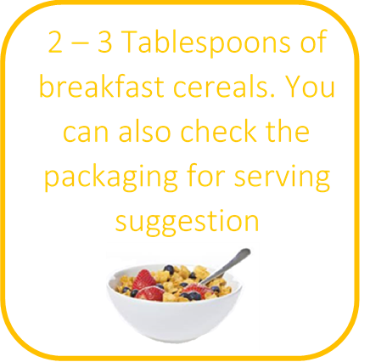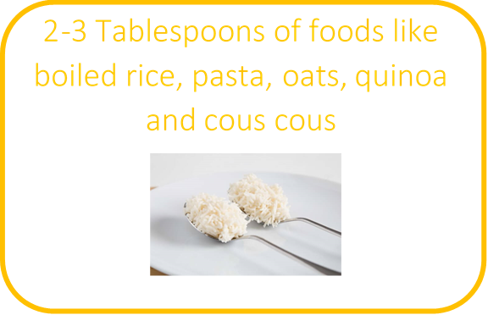

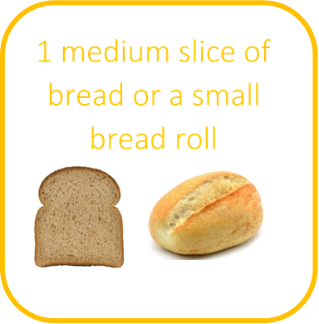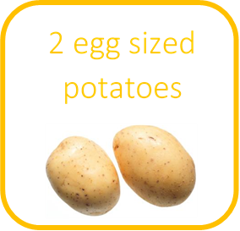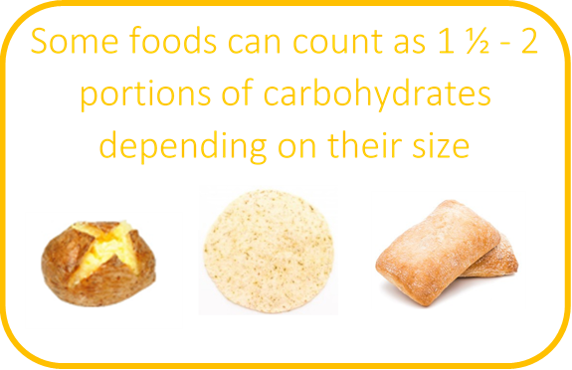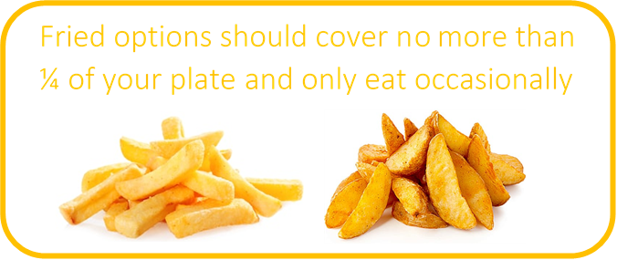

1 medium slice of bread or a small bread roll

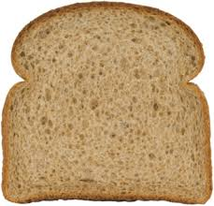

**Fruit & Vegetables**

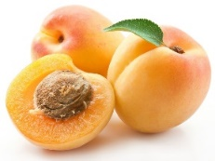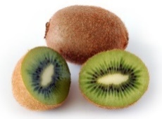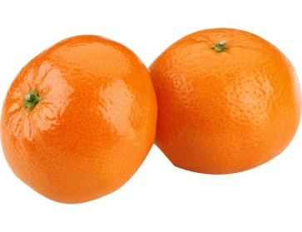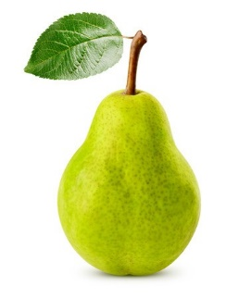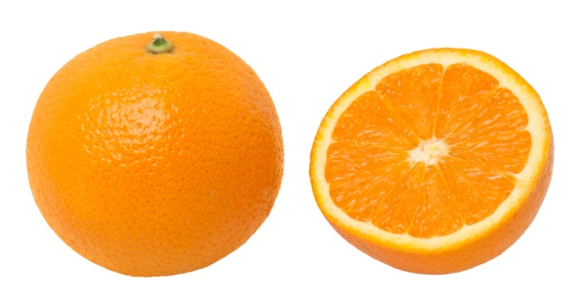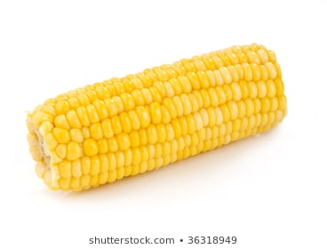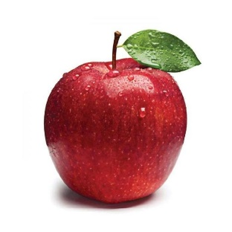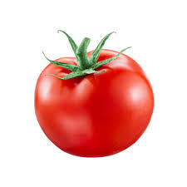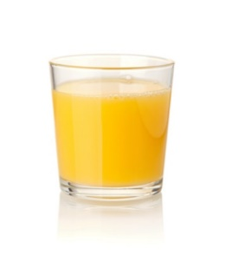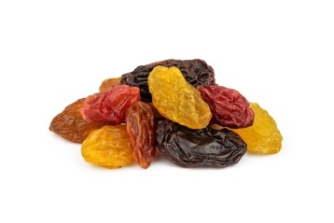**Aim for a minimum of 5 portions a day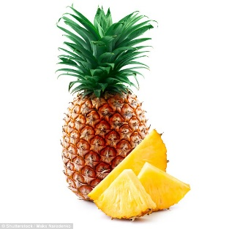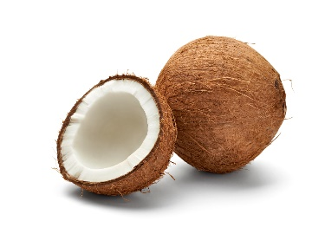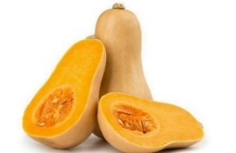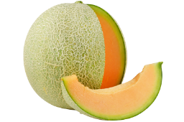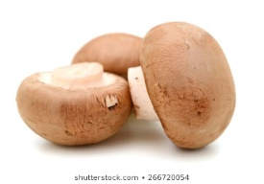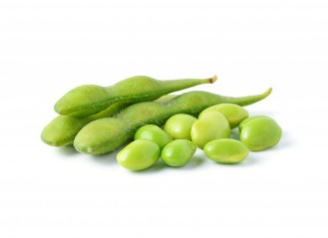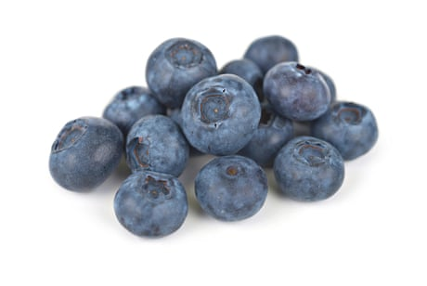**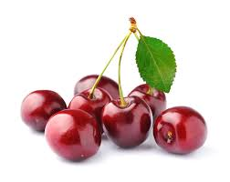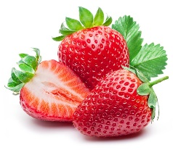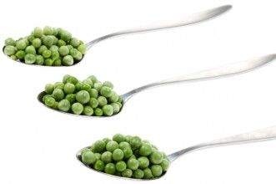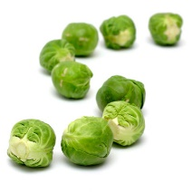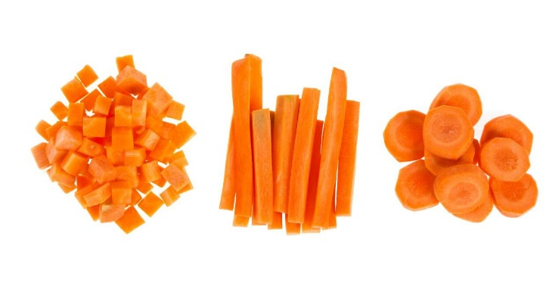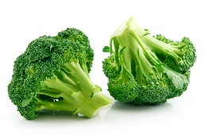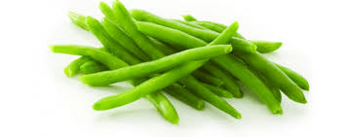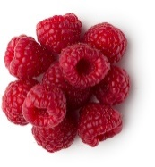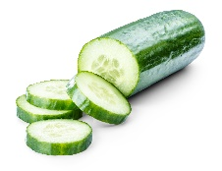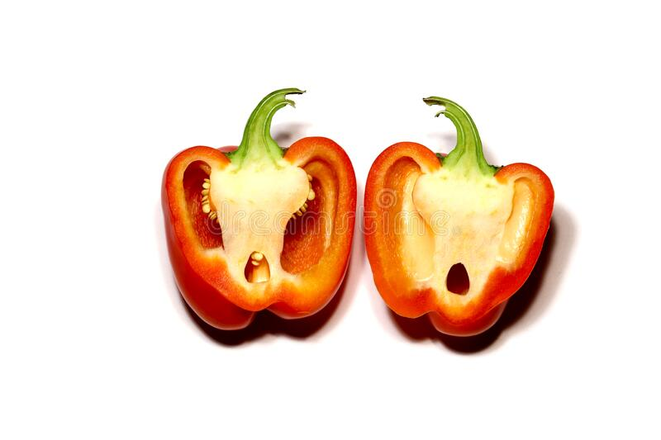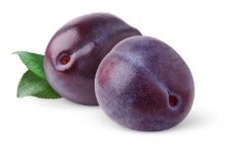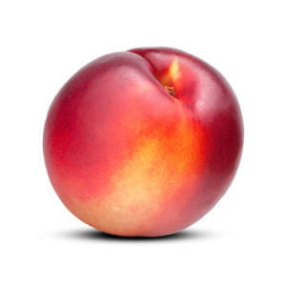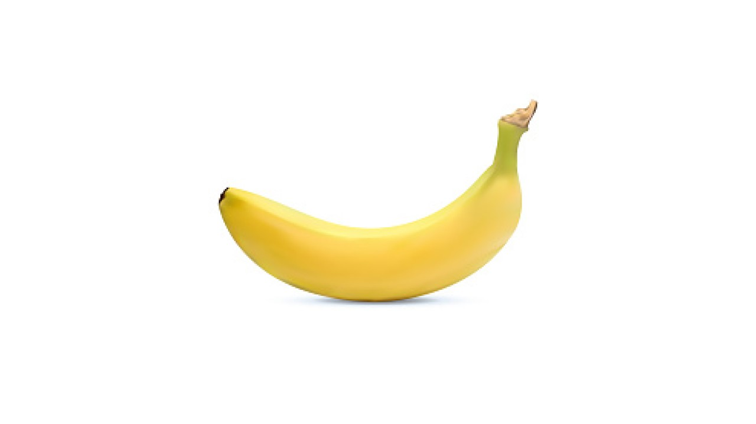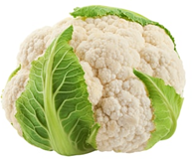

**A whole piece of medium-sized fruit or vegetable**

**30g or 1 tablespoon of dried fruit**

**Around 80g or a large slice of larger fruit and vegetables**

**Around 80g or 2-3 tablespoons of smaller fruit and vegetables**

**150ml of fresh juice or smoothie per day**

**2 smaller sized pieces of fruit or vegetables**

**Protein**

**Aim for 2-3 portions a day**

**What does a portion look like?**

An easy way of measuring a portion of protein suitable for you is to use your hand. So, for example…

Red meats such as beef, pork, lamb, and game meats should be about the   
size of your   
palm

Poultry such as chicken, turkey, duck, and foods like tofu, and nuts should be about the size of the palm of your hand

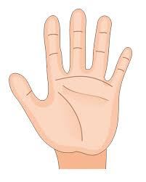

About 2-3 heaped tablespoons of beans and pulses

All fish should be about the size of your full hand and try to have 2 portions a week, one of which is oily

Oily fish include   
salmon,   
trout, herring,   
mackerel   
and sardines

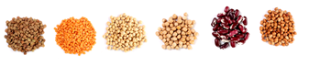

About 2-3 heaped tablespoons of cooked beans, lentils, and peas

About 2-3 heaped tablespoons of beans and pulses

Miscellaneous…  
2 eggs = 1 portion  
½ tin tuna and other fish  
2 sausages  
½ tin of baked beans

Miscellaneous…  
2 eggs = 1 portion  
½ tin tuna and other fish  
2 sausages  
½ tin of baked beans

Miscellaneous…  
2 eggs = 1 portion  
½ tin tuna and other fish  
2 sausages  
½ tin of baked beans

About 2-3 heaped tablespoons of beans and pulses

About 2-3 heaped tablespoons of beans and pulses or half a tin of baked beans.

About 2-3 heaped tablespoons of beans and pulses or half a tin of baked beans.

About 2-3 heaped tablespoons of beans and pulses or half a tin of baked beans.



Miscellaneous…1 portion =  
2 eggs   
½ tin tuna and other fish  
2 sausages  
½ 400g tin of baked beans

**Dairy**

**How much dairy should we eat?**As a rule, we should be aiming to consume around **2 - 3** portions of dairy products (or alternatives) a day. It is recommended that children under 2 years should be given whole milk, 3-5years whole or semi-skimmed milk and then 5+ into adulthood, any type is suitable. For those who are looking to maintain or reduce their weight, a reduced fat milk may be preferred. Whole milk is 4g fat per 100ml, semi-skimmed milk is 2% fat per 100ml, and skimmed milk is 0% fat per 100ml.

**What does a portion look like?**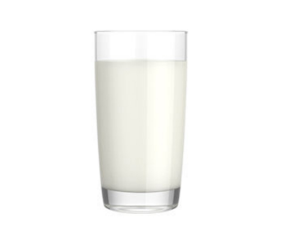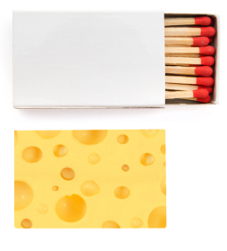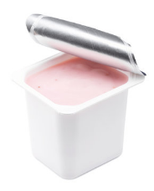

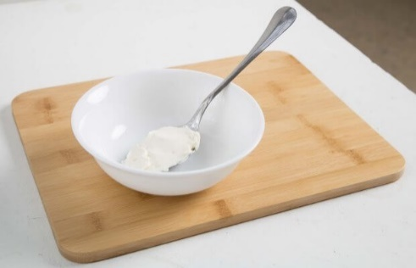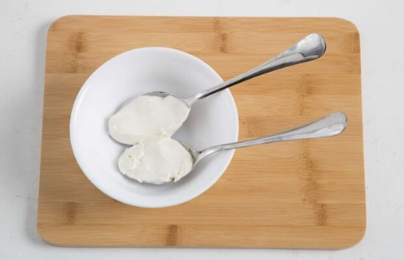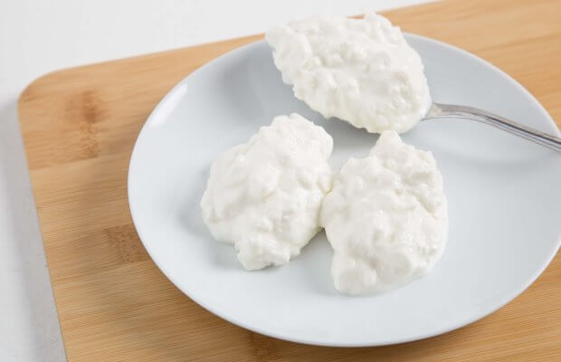

150g of yoghurt

A matchbox of cheese (30g)

200ml of milk

2-3 tablespoons of low-fat cottage cheese

2 tablespoons of low-fat cream cheese

1 tablespoons of full fat cream cheese

**Non-dairy sources of calcium include:**

* All fortified plant based dairy products
* Bread products made with fortified flour
* Tinned fish where the bones are also consumed, e.g. sardines, whitebait, salmon and pilchards.
* Fortified breakfast cereals
* Green leafy veg
* Fortified orange juice
* Chickpeas, chia seeds, sesame seeds, and some nuts.
* Dried fruit such as apricots, figs and dates

|  |  |
| --- | --- |
| Age | Calcium Needed (mg./day) |
| Adults 19 years + | 700 |
| During Pregnancy | 700 |
| Breastfeeding women | Add an extra 550 to requirements |
| Postmenopausal women | 1000 |

**Top tips for getting your dairy in**

* Have a mug of hot milky drinks such as Horlicks, low calorie hot chocolate before bed.
* Add milk or yoghurt to a milkshake or a smoothie.
* Freeze yoghurt blended with fruit as an alternative to ice cream.
* Add a spoon of yoghurt to your soups rather than cream.
* Use milk with breakfast cereals or porridge.
* Use milk in mashed potatoes.
* Try yoghurt with fruit as a snack or following a meal.
* Grate cheese onto jacket potatoes or main meals.
* Try cottage cheese or cream cheese with a salad, crackers, or jacket potato.

Vitamin D helps to regulate calcium and phosphate levels in our bodies. Both are needed for healthy bones, teeth, and muscles.

How much Vitamin D do I need?

Adults and children above 4 years old should aim for 10mcg/day (400UI/d) of Vitamin D.

Where can I find Vitamin D in food? Do I need to take supplements?

The main source of vitamin D is from the action of sunlight on our skin. There are very few foods where Vitamin D is found natural and they are mainly animal based products foods. Everyone in the United Kingdom is advised to take a vitamin D supplement from at least October to April, if not the full year, due to very low exposure of UV rays from the sun in the winter months. It is also found in food like breakfast cereal, vegetable spreads, and plant-based milk alternatives.

Dietary Sources of Vitamin D

Oily fish, red meat, liver, and egg yolks.

Fortified breakfast cereal, vegetable spreads, plant-based milk alternatives

**Fats**

**How much fat should we eat?**

Adults should limit fat intake to 70g per day with a maximum of 20g from saturated fat. A portion of fat is about 1 teaspoon (5g) of butter or spread and 1 teaspoon of oil (3g).

**So where do the different types of fat come from?**

Saturated fats and trans fats are found in animal products and processed meats but also palm oil, coconut oil, lard, ghee, suet, cocoa butter, cake, sweets, and pastries

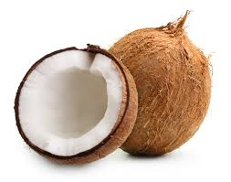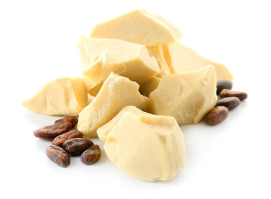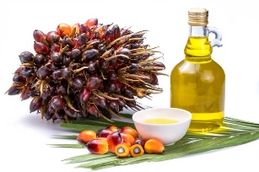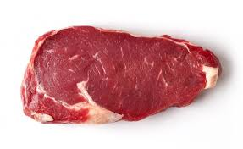

Polyunsaturated fats are found in oily fish, corn oil, sesame oil, soya oil, and spreads made from those oils. Flaxseed, pine nuts, sesame seeds, sunflower seeds, and walnuts.

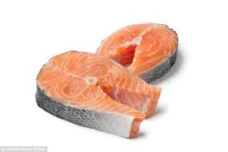

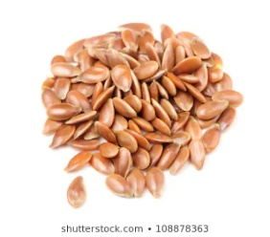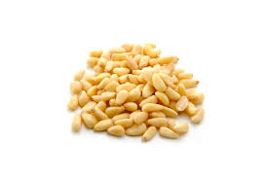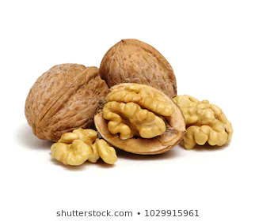

Monounsaturated fats are found in Avocados, olives, olive oil, and rapeseed oil. Nuts such almonds, cashews, hazelnuts, peanuts, pistachios and spreads made from these nuts.

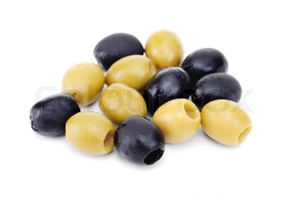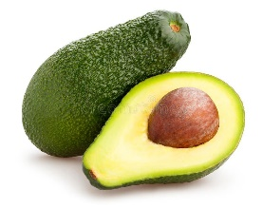

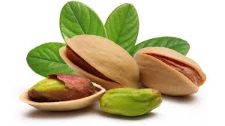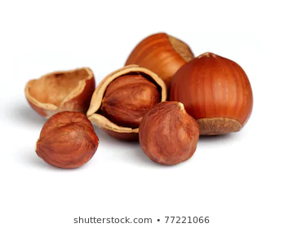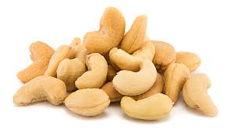

**Tips to help you reduce your saturated fat intake**

* Swap butter, lard, and ghee for a plant-based spread and use a smaller amount.
* Choose a lean cut of meat and remove any skin or visible fat before cooking.
* Use an oil spray rather than pouring straight from the bottle.
* Use food labels to guide your choices for a lower saturated fat variety.
* Try to grill, bake, steam, boil or poach rather than frying.
* Use low fat or reduced fat dairy products.